
FACULTY OF ENGINEERING
DIPLOMA ENGINEERING
DEPARTMENT OF COMPUTER ENGINEERING
ADVANCED COMPUTER NETWORK (DE103503)

Chapter-1:-Network Layer Protocols

1.1Network Layer Protocol
- Network layer protocols are a vital part of the internet infrastructure, responsible for routing and forwarding data packets between devices on a network. These protocols are used to ensure that data is delivered to the correct destination and in a timely manner.

There are several network layer protocols that are commonly used, each serving a specific purpose.
- Internet Protocol (IP): This protocol is responsible for addressing and routing data packets across the internet. It works by assigning a unique numerical address, called an IP address, to each device on a network. This allows data packets to be forwarded to the correct device based on the IP address.
- Internet Control Message Protocol (ICMP): This protocol is used to transmit error messages and other information between devices on a network. It is often used to troubleshoot network issues or to send diagnostic information.
- Address Resolution Protocol (ARP): This protocol is used to map IP addresses to physical addresses, such as a device’s media access control (MAC) address. This allows devices to communicate with each other on a network.
- Routing Information Protocol (RIP): The Routing Information Protocol (RIP) is another network layer protocol that is used to determine the best path for data packets to travel between devices on a network. It works by sending updates to other devices on the network, allowing them to update their routing tables and determine the best route for data packets.
- Open Shortest Path First (OSPF) protocol: This is a routing protocol that is used in large networks, such as enterprise networks or internet service providers. It works by using a link-state database to determine the best route for data packets and can quickly adapt to changes in the network.

1.2 IPV4 Addresses
Address space
  - An address space is a range of logical space on any part of a computer or peripheral device where data can be stored. For instance, on a memory chip, each byte of data has its own address where it can be stored and then located later. The address can be limited by the physical limitations of the device, and arbitrary limits that separate certain types of data from one another.
Classful addressing
  - Classful addressing is an IPv4 addressing architecture that divides addresses into five groups. Prior to classful addressing, the first eight bits of an IP address defined the network a given host was a part of. This would have had the effect of limiting the internet to just 254 networks.
  - The 32-bit IP address is divided into five sub-classes.

These are:

    - Class A

Class B
    - Class C

Class D
    - Class E

- Class A

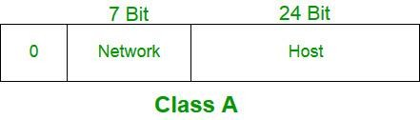
- IP addresses belonging to class A are assigned to the networks that contain a large number of hosts.
- The network ID is 8 bits long.
- The host ID is 24 bits long.
- The higher-order bit of the first octet in class A is always set to 0. The remaining 7 bits in the first octet are used to determine network ID. The 24 bits of host ID are used to determine the host in any network. The default subnet mask for Class A is 255.x.x.x. Therefore, class A has a total of: 2^7-2= 126 network ID(Here 2 address is subtracted because 0.0.0.0 and 127.x.y.z are special address. )
2^24 – 2 = 16,777,214 host ID
- IP addresses belonging to class A ranges from 1.x.x.x – 126.x.x.x

- Class B

  - IP address belonging to class B is assigned to networks that range from medium-sized to large-sized networks.
  - The network ID is 16 bits long.
  - The host ID is 16 bits long.
  - The higher-order bits of the first octet of IP addresses of class B are always set to 10. The remaining 14 bits are used to determine the network ID. The 16 bits of host ID are used to determine the host in any network. The default subnet mask for class B is 255.255.x.x. Class B has a total of:
  - 2^14 = 16384 network address
  - 2^16 – 2 = 65534 host address
  - IP addresses belonging to class B ranges from 128.0.x.x – 191.255.x.x.

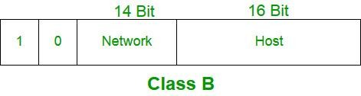Class C

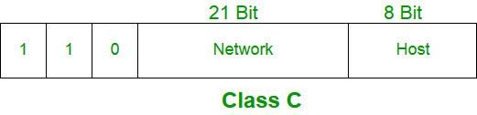
- IP addresses belonging to class C are assigned to small-sized networks.
- The network ID is 24 bits long.
- The host ID is 8 bits long.
- The higher-order bits of the first octet of IP addresses of class C is always set to 110. The remaining 21 bits are used to determine the network ID. The 8 bits of host ID are used to determine the host in any network. The default subnet mask for class C is 255.255.255.x. Class C has a total of:
- 2^21 = 2097152 network address
- 2^8 – 2 = 254 host address
- IP addresses belonging to class C range from 192.0.0.x – 223.255.255.x.

- Class D

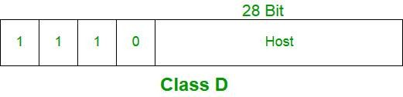
- IP address belonging to class D is reserved for multi-casting. The higher-order bits of the first octet of IP addresses belonging to class D is always set to 1110. The remaining bits are for the address that interested hosts recognize.
- Class D does not possess any subnet mask. IP addresses belonging to class D range from 224.0.0.0 – 239.255.255.255.

- Class E

  - IP addresses belonging to class E are reserved for experimental and research purposes. IP addresses of class E range from 240.0.0.0 – 255.255.255.254. This class doesn’t have any subnet mask. The higher- order bits of the first octet of class E are always set to 1111.

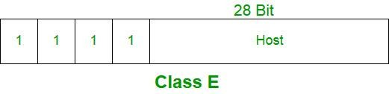Range of Special IP Addresses
169.254.0.0 – 169.254.0.16: Link-local addresses
127.0.0.0 – 127.0.0.8: Loop-back addresses
0.0.0.0 – 0.0.0.8: used to communicate within the current network.

Network Address Resolution (Translation)

  - NAT (Network Address Translation) connects two networks and maps the private (inside local) addresses into public addresses (inside global).
  - Inside local denotes that the best address belonged to an internal network and was not assigned by a Network Information Centre or service power.
  - The inside global signifies that the address is a valid address assigned by the NIC or service provider, and one or more inside local addresses to the outside world.

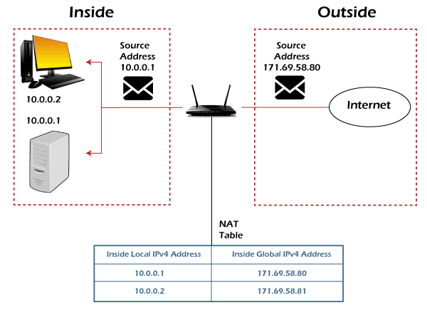

NAT is a method of converting a private IP address or a local address into a public IP address. NAT is a technique for reducing the rate at which available IP addresses are depleted by translating a local IP or private IP address into a global or public IP address. The NAT relation might be one-to-one or many-to-one.
  - Furthermore, NAT can only configure one address in order to represent the entire network to the outside world. As a result, the translation process is transparent. NAT can be used to migrate and merge networks, share server loads, and create virtual servers, etc.

Types of NAT :There are three types of NAT

Static NAT
In static NAT, a local address is mapped to a global address. In this type of NAT, the relationship is one-to-one. Static NAT is used if a host needs a consistent address that must be acceded from the internet. For example, networking devices or enterprise servers.

Dynamic NAT
Unregistered private IP addresses can be converted to registered public IP numbers from a pool of public IP addresses using dynamic NAT.

Dynamic NAT
Unregistered private IP addresses can be converted to registered public IP numbers from a pool of public IP addresses using dynamic NAT
Advantages of NAT

The following are the advantages of NAT:
- NAT protects the public addresses that have been registered and slow down the IP address space exhaustion.
- Removes the address renumbering process that occurs when switching networks
- The occurrence of address overlap was significantly reduced.
- Increases flexibility of the connection establishment.

Disadvantages of NAT

The following are the disadvantages of NAT:

  - Lack of end-to-end traceability
  - Certain applications are not compatible with NAT
  - Switching path delays are the outcome of the translation

1.3 Forwarding of IP Packets
- The process of packet forwarding simply implies the forwarding of incoming packets to their intended destination.
- Internet is made up of generally two terms- Interconnection and Network. So, it is a connection to a large collection of networks. A packet that is to be forwarded may be associated with the same network as the source host or may belong to a destination host in a different network. Thus, it depends on the destination how much a packet may need to travel before arriving at its destination.
- The router is responsible for the process of packet forwarding. It accepts the packet from the origin host or another router in the packet’s path and places it on the route leading to the target host.
- The routing table is maintained by the router which is used for deciding the packet forwarding.

Packet Forwarding in Router:

- Routers are used on the network for forwarding a packet from the local network to the remote network. So, the process of routing involves the packet forwarding from an entry interface out to an exit interface.

Working:

  - The following steps are included in the packet forwarding in the router-
  - The router takes the arriving packet from an entry interface and then forwards that packet to another interface.

  - The router needs to select the best possible interface for the packet to reach the intended destination as there exist multiple interfaces in the router.
  - The forwarding decision is made by the router based on routing table entries. The entries in the routing table comprise destination networks and exit interfaces to which the packet is to be forwarded.
  - 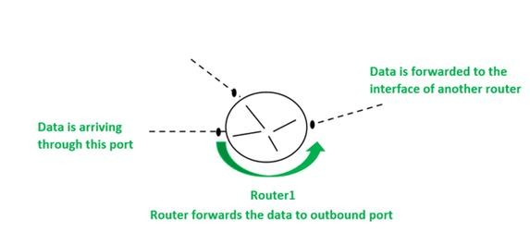The selection of exit interface relies on- firstly, the interface must lead to the target network to which the packet is intended to send, and secondly, it must be the best possible path leading to the destination network.

Forwarding based on destination address

Following are the packet forwarding techniques based on the destination host:

  - Next-Hop Method: By only maintaining the details of the next hop or next router in the packet’s path, the next-hop approach reduces the size of the routing table. The routing table maintained using this method does not have the information regarding the whole route that the packet must take.
  - Network-Specific Method: In this method, the entries are not made for all of the destination hosts in the router’s network. Rather, the entry is made of the destination networks that are connected to the router.
  - Host-Specific Method: In this method, the routing table has the entries for all of the destination hosts in the destination network. With the increase in the size of the routing table, the efficiency of the routing table decreases. It finds its application in the process of verification of route and security purposes.
  - Default Method: Let’s assume- A host in network N1 is connected to two routers, one of which (router R1) is connected to network N2 and the other router R2 to the rest of the internet. As a result, the routing table only has one default entry for the router R2.

1.4 Internet Protocol
  - IPv4 was developed in 1981, and it’s still widely used. It uses 32-bit address space.
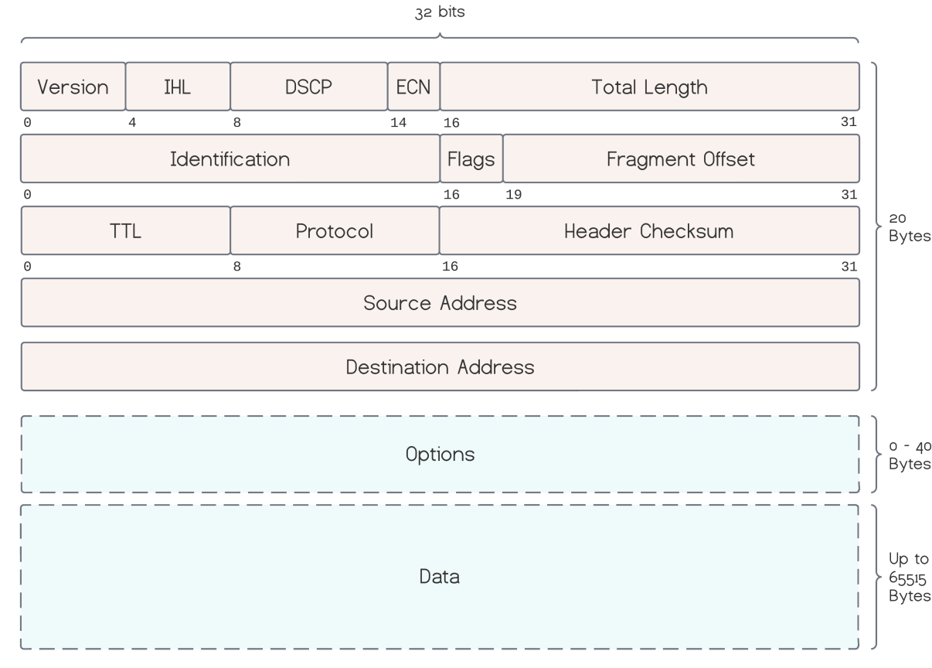
1. Version

  - IP version field set to 4 for IPv4.

Internet Header Length

- IHL is the number of 32-bit words making up the header field. As the first 20 bytes are mandatory, the minimum number is 5, and the maximum is 15.

Differentiated Services Code Point (DSCP)

  - It specifies the type of service for differentiated services, such as voice-over IP.

Explicit Congestion Notification (ECN)

  - ECN carries a network congestion notification without dropping packets or wasting bandwidth when supported.

Total Length

  - It represents the total size of the datagram, including the header and the data segment.

Identification

  - This field uniquely identifies the group of fragments of a single IP datagram.

Flags

  - Different combinations of the flags control the fragmentation and indicate fragmented datagrams.
  - For example, if the don’t fragment flag (bit 1) is set to 1, and the destination host can’t assemble the fragmented packets, it will drop them.

Fragment Offset

  - It contains the offset of a fragmented packet.

Time to Live (TTL)

  - The number of hops a packet lives. Each router decrements the TTL field and discards the packet when it reaches 0. This way, looping packets are eliminated.

Protocol

  - It’s the protocol for the data part.

Header Checksum

  - It’s a checksum for error detection, covering only the header field. Each router checks this value and discards the packet if an error is detected. Uncorrupted packets return 0 when summing the whole header, including the checksum itself.

Source Address

  - Source host IPv4 address.

Destination Address

  - Destination host IPv4 address.

Options

  - Additional options are stored in this field when present.
 | 17 or 18 | Address mask request or reply
 | 10 or 9 | Router Solicitation or advertisement
Security of IPv4 Datagrams

- Pv4 security permits encryption to keep up privacy and security. IPV4 network allocation is significant and presently has quite 85000 practical routers. It becomes easy to attach multiple devices across an outsized network while not NAT.
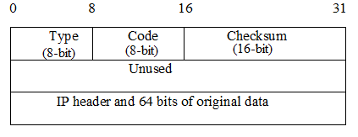Source Quench − It requests to decrease the traffic rate of message sending from source to destination.
  - Time Exceeded − When fragments are lost in a network the fragments hold by the router will be dropped and then ICMP will take the source IP from the discarded packet and inform the source, that datagram is discarded due to the time to live field reaches zero, by sending time exceeded message.
  - Fragmentation Required − When a router is unable to forward a datagram because it exceeds the MTU of the next-hop network and the DF (Don't Fragment) bit is set, the router is required to return an ICMP Destination Unreachable message to the source of the datagram, with the Code indicating fragmentation is needed and DF (Don’t Fragment) set.
  - Destination Unreachable − This error message indicates that the destination host, network, or port number that is specified in the IP packet is unreachable. This may happen due to the destination host device is down, an intermediate router is unable to find a path to forward the packet, and a firewall is configured to block connections from the source of the packet.
  - Redirect Message − A redirect error message is used when a router needs to tell a sender that it should use a different path for a specific destination. It occurs when the router knows a shorter path to the destination.

ICMP Basic Error Message Format
A basic ICMP error message would have the following format −

- Type − The type field identifies the type of the message.
- Code − The code field in ICMP describes the purpose of the message.
- Checksum − The checksum field is used to validate ICMP messages.

ICMP checksum

  - Message Data: The ICMP checksum covers the entire ICMP message, including the ICMP header and any data payload. The data payload can vary depending on the type and code of the ICMP message. For example, in an ICMP Echo Request (ping) packet, the data payload typically includes a sequence number and a timestamp.
  - Pseudo-Header: In addition to the ICMP message itself, the checksum calculation includes a pseudo- header, which is derived from the IP packet header of the packet carrying the ICMP message. This pseudo-header includes the source IP address, destination IP address, and a fixed field (all set to 0x00) for protocol type (ICMP).
  - Calculation: To calculate the checksum, the data in the ICMP message and the pseudo-header is treated as a series of 16-bit words. The checksum is initially set to 0x0000. Then, each 16-bit word is added to the checksum, and any overflow from the addition is wrapped around. Finally, the checksum is complemented (bitwise NOT) to get the final checksum value.
  - Placement: The calculated checksum value is then placed in the ICMP checksum field within the ICMP header.

